Daily Sales Loader
Code:
import os
import logging
from datetime import datetime, timedelta

import pandas as pd

from airflow import DAG
from airflow.operators.python import PythonOperator
from airflow.providers.snowflake.hooks.snowflake import SnowflakeHook
from airflow.exceptions import AirflowException

logger = logging.getLogger(__name__)

def create_table():

try:

hook = SnowflakeHook(
snowflake_conn_id='snowflake_default'
)

create_table_sql = """
CREATE TABLE IF NOT EXISTS RAW_SALES (
order_id INT,
product VARCHAR,
quantity INT,
unit_price FLOAT,
sale_date DATE,
region VARCHAR,
loaded_at TIMESTAMP
);
"""

hook.run(create_table_sql)

logger.info("Table RAW_SALES ready.")

except Exception as e:

logger.error(
f"Error while creating RAW_SALES table: {str(e)}"
)

raise AirflowException(
f"create_table task failed: {str(e)}"
)

def clear_todays_data():

try:

hook = SnowflakeHook(
snowflake_conn_id='snowflake_default'
)

count_query = """
SELECT COUNT(*)
FROM RAW_SALES
WHERE loaded_at::DATE = CURRENT_DATE();
"""

deleted_rows = hook.get_first(count_query)[0]

delete_query = """
DELETE FROM RAW_SALES
WHERE loaded_at::DATE = CURRENT_DATE();
"""

hook.run(delete_query)

logger.info(
f"Deleted {deleted_rows} rows from RAW_SALES."
)

except Exception as e:

logger.error(
f"Error while clearing today's data: {str(e)}"
)

raise AirflowException(
f"clear_todays_data task failed: {str(e)}"
)

def load_csv_to_snowflake():
try:
file_path = "data/sales_data.csv"

if not os.path.exists(file_path):
raise AirflowException(
f"CSV file not found: {file_path}"
)

df = pd.read_csv(file_path)

hook = SnowflakeHook(
snowflake_conn_id="snowflake_default"
)

for _, row in df.iterrows():

product = str(row['product']).replace("'", "''")
region = str(row['region']).replace("'", "''")

insert_sql = f"""
INSERT INTO RAW_SALES (
order_id,
product,
quantity,
unit_price,
sale_date,
region,
loaded_at
)
VALUES (
{row['order_id']},
'{product}',
{row['quantity']},
{row['unit_price']},
'{row['sale_date']}',
'{region}',
CURRENT_TIMESTAMP()
)
"""

try:

hook.run(insert_sql)

except Exception as e:

logger.error(
f"Failed inserting order_id "
f"{row['order_id']}: {str(e)}"
)

raise AirflowException(
"CSV load failed."
)

logger.info(
f"Loaded {len(df)} rows into RAW_SALES."
)
except Exception as e:

logger.error(
f"Error in load_csv_to_snowflake: {str(e)}"
)

raise AirflowException(
f"load_csv_to_snowflake failed: {str(e)}"
)

def transform_in_snowflake():

try:

hook = SnowflakeHook(
snowflake_conn_id='snowflake_default'
)

# Create summary table
create_summary_table = """
CREATE TABLE IF NOT EXISTS SALES_SUMMARY (
region VARCHAR,
total_orders INT,
total_revenue FLOAT,
avg_order_value FLOAT,
summary_date DATE
);
"""

hook.run(create_summary_table)

logger.info("SALES_SUMMARY table ready.")

# Idempotency delete
delete_query = """
DELETE FROM SALES_SUMMARY
WHERE summary_date = CURRENT_DATE();
"""

hook.run(delete_query)

logger.info(
"Deleted today's existing SALES_SUMMARY rows."
)

# Insert transformed data
insert_query = """
INSERT INTO SALES_SUMMARY (
region,
total_orders,
total_revenue,
avg_order_value,
summary_date
)
SELECT
region,
COUNT(*),
SUM(quantity * unit_price),
AVG(quantity * unit_price),
CURRENT_DATE()
FROM RAW_SALES
WHERE loaded_at::DATE = CURRENT_DATE()
GROUP BY region;
"""

hook.run(insert_query)

count_query = """
SELECT COUNT(*)
FROM SALES_SUMMARY
WHERE summary_date = CURRENT_DATE();
"""

region_count = hook.get_first(count_query)[0]

logger.info(
f"{region_count} region summary rows written."
)

except Exception as e:

logger.error(
f"Error in transform_in_snowflake: {str(e)}"
)

raise AirflowException(
f"transform_in_snowflake failed: {str(e)}"
)

def quality_check():

try:

hook = SnowflakeHook(
snowflake_conn_id='snowflake_default'
)

row_count_query = """
SELECT COUNT(*)
FROM RAW_SALES
WHERE loaded_at::DATE = CURRENT_DATE();
"""

row_count = hook.get_first(
row_count_query
)[0]

if row_count == 0:

logger.error(
"FAIL: No rows found in RAW_SALES."
)

raise AirflowException(
"Quality Check Failed: No rows loaded."
)

logger.info(
f"PASS: Row count check passed. Rows = {row_count}"
)

null_check_query = """
SELECT COUNT(*)
FROM RAW_SALES
WHERE product IS NULL
OR unit_price IS NULL;
"""

null_count = hook.get_first(
null_check_query
)[0]

if null_count > 0:

logger.warning(
f"WARNING: Found {null_count} NULL rows."
)

else:

logger.info(
"PASS: NULL check passed."
)

negative_price_query = """
SELECT COUNT(*)
FROM RAW_SALES
WHERE unit_price < 0;
"""

negative_count = hook.get_first(
negative_price_query
)[0]

if negative_count > 0:

logger.error(
f"FAIL: Found {negative_count} negative prices."
)

raise AirflowException(
"Quality Check Failed: Negative prices found."
)

logger.info(
"PASS: Negative price check passed."
)

logger.info(
"All quality checks completed successfully."
)

except Exception as e:

logger.error(
f"Error in quality_check: {str(e)}"
)

raise AirflowException(
f"quality_check failed: {str(e)}"
)

def print_report():

try:

hook = SnowflakeHook(
snowflake_conn_id='snowflake_default'
)

report_query = """
SELECT
region,
total_orders,
total_revenue,
avg_order_value
FROM SALES_SUMMARY
WHERE summary_date = CURRENT_DATE();
"""

report_data = hook.get_records(
report_query
)

logger.info(
"========== SALES REPORT =========="
)

grand_total = 0

for row in report_data:

region = row[0]
total_orders = row[1]
total_revenue = row[2]
avg_order_value = row[3]

grand_total += total_revenue

logger.info(
f"""
Region: {region}
Total Orders: {total_orders}
Total Revenue: {total_revenue}
Average Order Value: {avg_order_value}
"""
)

logger.info(
f"GRAND TOTAL REVENUE: {grand_total}"
)

logger.info(
"========== END REPORT =========="
)

except Exception as e:

logger.error(
f"Error in print_report: {str(e)}"
)

raise AirflowException(
f"print_report failed: {str(e)}"
)

default_args = {
'owner': 'airflow',
'retries': 2,
'retry_delay': timedelta(minutes=5)
}

with DAG(
dag_id='daily_sales_loader',
schedule='@daily',
start_date=datetime(2023, 1, 1),
catchup=False,
default_args=default_args
) as dag:

create_table_task = PythonOperator(
task_id='create_table',
python_callable=create_table
)

clear_todays_data_task = PythonOperator(
task_id='clear_todays_data',
python_callable=clear_todays_data
)

load_csv_task = PythonOperator(
task_id='load_csv_to_snowflake',
python_callable=load_csv_to_snowflake
)

transform_task = PythonOperator(
task_id='transform_in_snowflake',
python_callable=transform_in_snowflake
)

quality_check_task = PythonOperator(
task_id='quality_check',
python_callable=quality_check
)

print_report_task = PythonOperator(
task_id='print_report',
python_callable=print_report
)

create_table_task >> clear_todays_data_task >> load_csv_task >> transform_task >> quality_check_task >> print_report_task

- Graph View — all 6 tasks GREEN in correct sequence
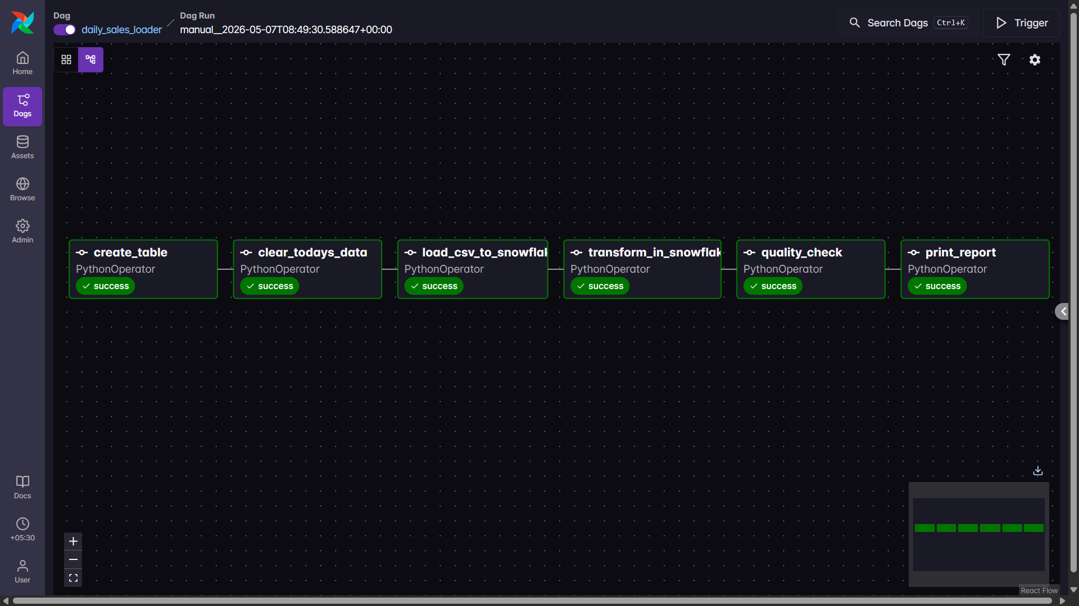

- Snowflake Worksheet — SELECT * FROM RAW_SALES showing loaded rows with loaded_at column
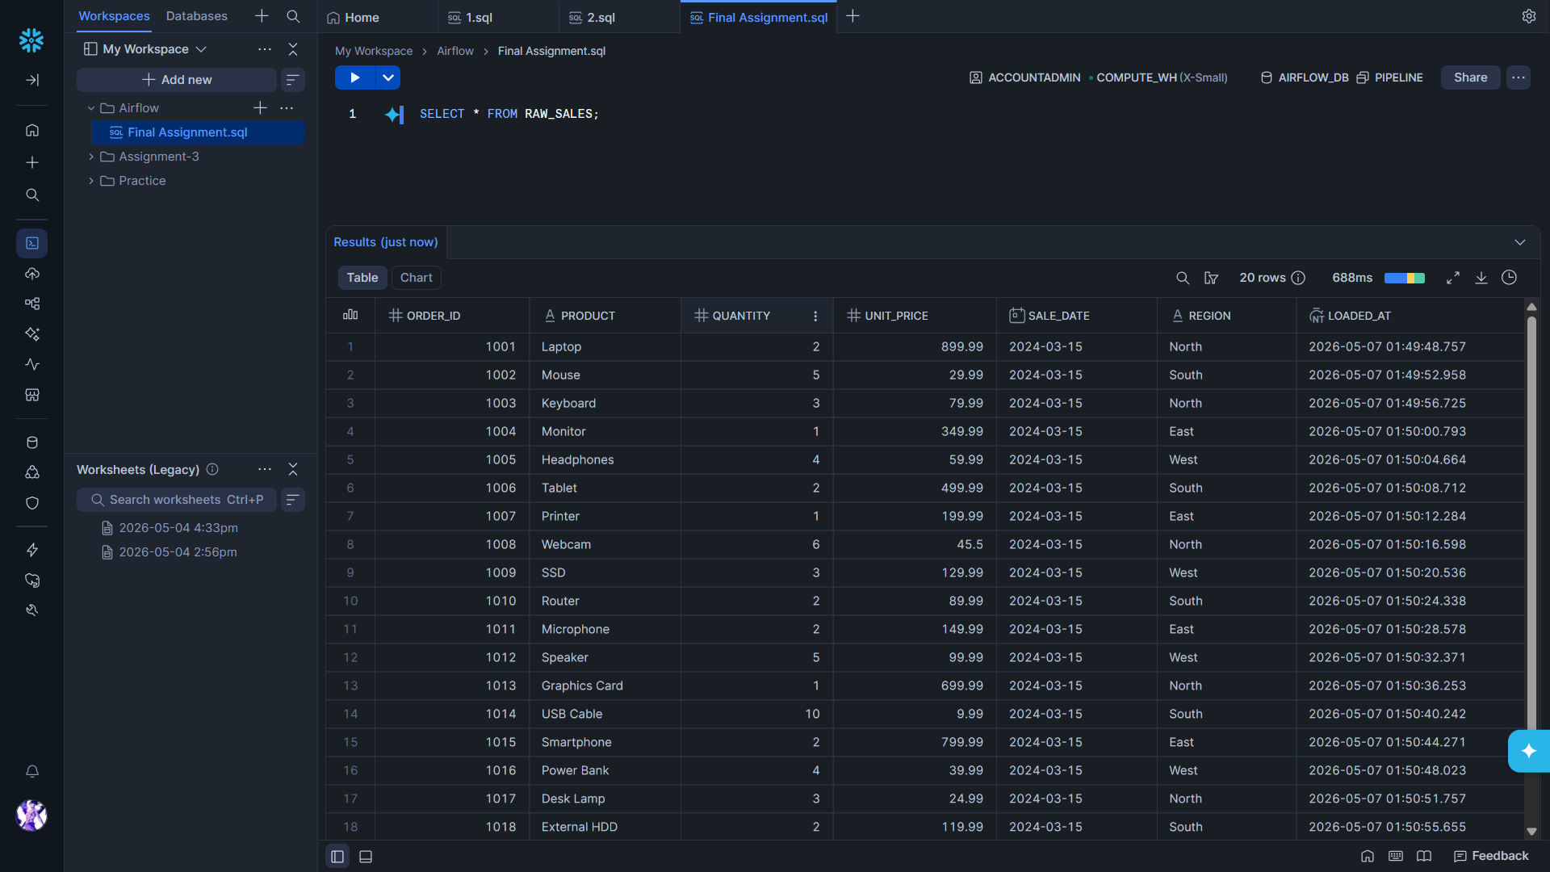
- Snowflake Worksheet — SELECT * FROM SALES_SUMMARY showing grouped revenue per region
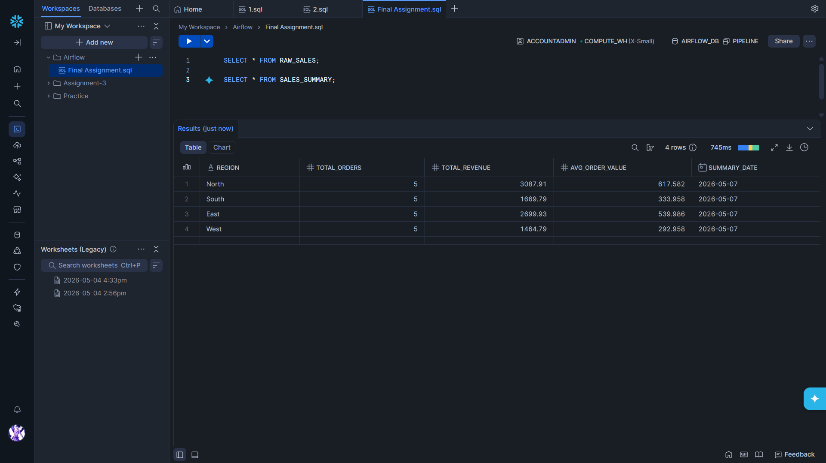

- Task Log of quality_check — PASS printed for all 3 checks with the actual values shown
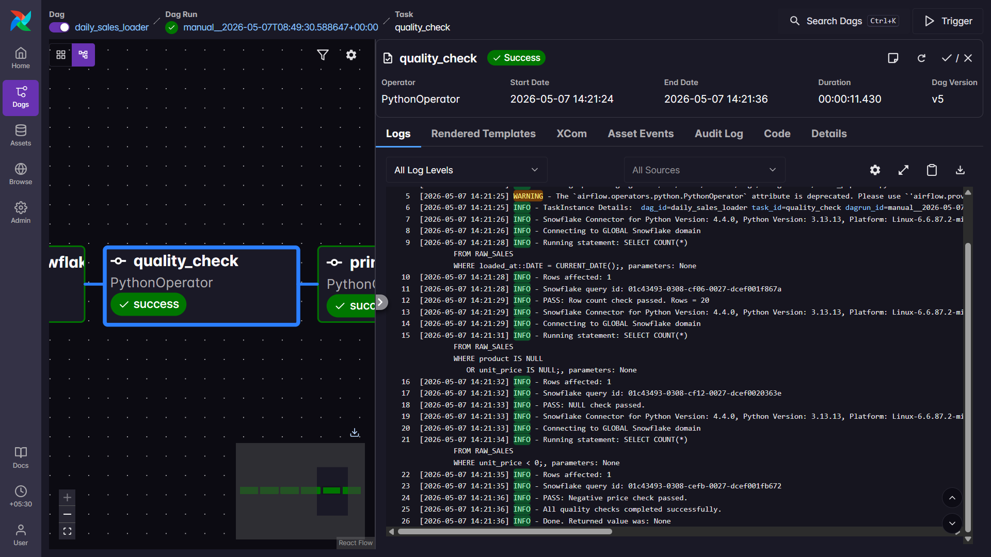

- Task Log of print_report — formatted region report with grand total revenue
